PLEASE READ CAREFULLY THIS DOCUMENT ABOUT REGISTRATION PROCESS

Here is your guide for sign up for Global Leaders platform. watch carefully and follow all steps in order to succesfully register.

- Make sure you download TRONLINK APP WALLET . For Google browser on your computer, laptop you need to install Google Chrom extension. For mobile app, IOS and Android, you will need to download and install TRONLINK app on your mobile phone.

Everything about in detail installation TRONLINK on your browser or mobile phone you can find in this in details article TRONLINK INSTALLATION PROCESS

- In process of setting up TRONLINK on your computer/phone, please be cautious, create hard password, AND COLD STORAGE your BACKUP KEY AND MNEMONIC PHRASE in case of loosing access to be able to recover your account on TRONLINK. We are not able to help you in case of loosing data, as we are not having/using your private keys, and we are NOT keeping/holding your assets on any part of Global Leaders platform.

Everything about in detail installation TRONLINK on your browser or mobile phone you can find in this in details article TRONLINK INSTALLATION PROCESS

3. Fund your TRONLINK wallet. In order to register and operate into the system it is mandatory to have TRX on your account on TRONLINKWALLET, as we are using TRX blockchain network in part of compensation plan, deposits/withdrawals and exchange on our platform. Reccomended amount is to have always 100+ TRX on your TRONLINK wallet for all gas fees you will meet during the process.

4. Exchange. To be able to deposit our token GLT true the platform, first thing you need to do is to deposit USDT ( TRC20 ) on your TRONLINK wallet. Example, if you want to participate in vip.globalleaders.vip which is platform that operates with 1000GLT, you will need to deposit into your TRONLINK wallet 1030 USDT ( TRC 20 ) to be able to buy GLT true our exchange. Don't forget also to have 100+ TRX on the same wallet in TRONLINK. After depositing USDT and TRX into your wallet, you will proceed then to URL vip.globalleaders.vip via Google chrome, platform will ask you to CONNECT your wallet to our platform, you need to click APROVE. In next step, you will press button on the top of the screen EXCHANGE, you will insert that you want to change USDT to GLT, you will insert the amount of 1030 USDT and then click submit. There will then pop up new window that will ask to confirm that, where you again need to click APROVE. In that moment transactions is happening and you will need to WAIT! on that window until process is done (usualy under the minute, but please be patient and wait for the green notice on the screen). After the success notice, you can navigate from that window and check balance in you wallet where you now have GLT tokens in amount of 1030. You are now ready to register.

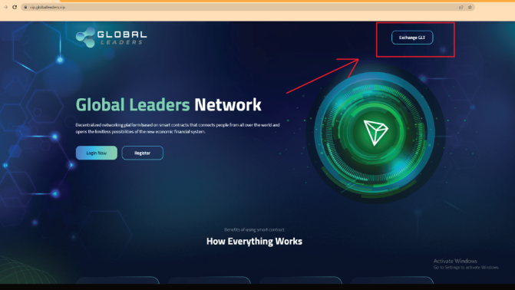

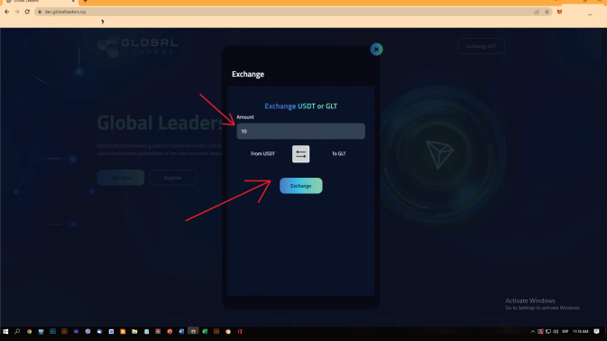

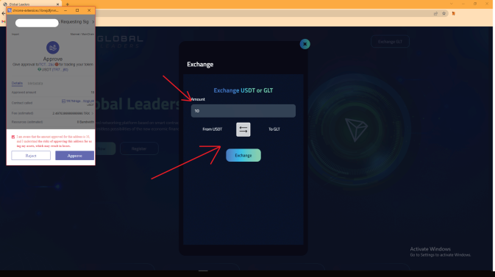
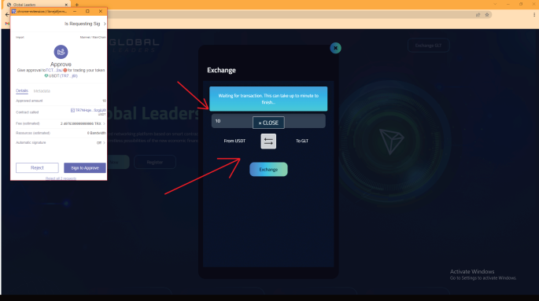

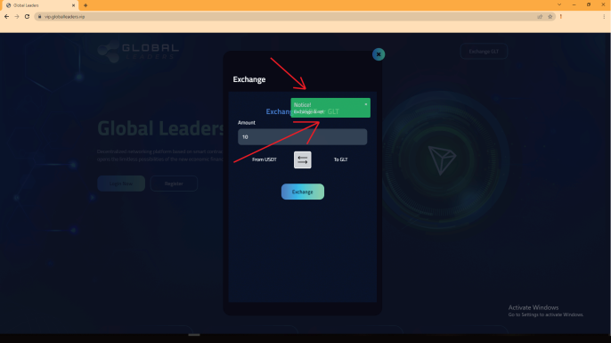

5. Registration. Only way to be registered into the system is by referal code of your upline, entrepreneur that invites you to join.He will provide you that. When you have referal link paste into the browser just click enter and you will be brought to the registration pop up, where you will press REGISTER button. In that moment registration process is activated and there comes second pop up, where TRONLINK ask you do you aprove trnasfer of GLT tokens to the Global Leaders platform + fees, you need to click APROVE. After that there is third pop up, that asks you, are you sure you want to pay XZY ammount to Global Leaders, you should click PAY. Process is started and there will be again a notice to WAIT on the page ( DO NOT NAVIGATE FROM THE PAGE AS PROCESS MAY FAIL! ) , if process is success there will be again green notice about it. Congratulations, you are now registered into the system. Press LOG IN and enter your account.

